SUMMATIVE ASSESSMENT MEMO

COMPUTERS, DEVICES AND COMPUTING SYSTEMS

Module Code | 252901001-KM-07
NQF Level | 4
Credits | 6
Curriculum Code | 252901001
Qualification Title | Occupational Certificate: Cybersecurity Analyst
SAQA QUAL ID | 118986

Name
Contact Address
Telephone (H)
Telephone (W)
Facsimile
Cellular
E-mail

Note to the learner
This Learner Guide provides a comprehensive overview of the module. It is designed to improve the skills and knowledge of learners, and thus enabling them to effectively and efficiently complete specific tasks.
Entry Requirements

- NQF 4
Provider Accreditation Requirements for the Knowledge Module

Physical Requirements
- The provider must have lesson plans and structured learning material or provide learners with access to structured learning material that addresses all the topics in all the knowledge modules as well as the applied knowledge in the practical skills.
- QCTO/ MICT SETA requirements

Human Resource Requirements:
- Lecturer/learner ratio of 1:20 (Maximum)
- Qualification of lecturer (SME):
    - NQF 6 in industry recognised qualifications with 1 years’ experience in the IT industry
    - CYBERSECURITY vendor certification
- Assessors and moderators: accredited by the MICT SETA
Legal Requirements
- Legal (product) licences to use the software for learning and training
- OHS compliance certificate
- Ethical clearance (where necessary)
Module Purpose
The main focus of the learning in this knowledge module is to build an understanding of what computers can do, and the processes that make them function in terms of the four major parts: the input, output, CPU (central processing unit), and memory. It gives an overview of networks and connectivity

Topic elements to be covered include
The learning will enable learners to demonstrate an understanding of:
- KM-07-KT01: Problem solving skills for IT Professionals
- KM-07-KT02: Techniques for safety
- KM-07-KT03: System components
- KM-07-KT04: Motherboards
- KM-07-KT05: Processors
- KM-07-KT06: Memory
- KM-07-KT07: BIOS and CMOS
- KM-07-KT08: Hard drives and storage devices
- KM-07-KT09: Power supplies and voltage
- KM-07-KT10: Ports, cables, and connectors
- KM-07-KT11: Input and output devices
- KM-07-KT12: Installing and managing printers
- KM-07-KT13: Mobile devices, multimedia, and laptop computers
- KM-07-KT14: Preventative maintenance
- KM-07-KT15: Troubleshooting procedures
- KM-07-KT16: Operating systems
- KM-07-KT17: Managing files
- KM-07-KT18: Applications utility, troubleshooting, and optimization
- KM-07-KT19: Configuring device drivers
- KM-07-KT20: Networking and wireless connections
- KM-07-KT21: Recovery
- KM-07-KT22: Cloud computing
- KM-07-KT23: Security fundamentals
- KM-07-KT24: Introduction to applications

Venue, Date and Time:
Consult your facilitator should there be any changes to the venue, date and/or time.
Refer to your timetable
Assessments

The only way to establish whether you are competent and have accomplished the learning outcomes is through continuous assessments. This assessment process involves interpreting evidence about your ability to perform certain tasks. You will be required to perform certain procedures and tasks during the training programmer and will be assessed on them to certify your competence.

This module includes assessments in the form of self-evaluations/activities and exercises. The exercises, activities and self-assessments will be done in pairs, groups or on your own. These exercises/activities or self-assessments (Learner workbook) must be handed to the facilitator. It will be added to your portfolio of evidence, which will be proof signed by your facilitator that you have successfully performed these tasks.

Listen carefully to the instructions of the facilitator and do the given activities in the time given to you.

KM-07-KT01: Problem solving skills for IT Professionals
Question
1
Describe the steps to protect your computer from Cyber Threats
Backup, Boot Disk, Computer, Cyber Threats, Extension, Filename, Firewall, Internet, Safety, Security, Software, Update, Virus, Web, Web Browser
Many people depend on their home computer to conduct essential business for both their professional and personal life. For example, more employees are now working remotely from home. Many consumers use their computing devices to shop, bank, and pay bills online. All of these are highly personal activities, as well as highly lucrative targets for hackers and identity thieves. You would never want your private data to fall into the wrong hands. That’s why you must protect yourself from malicious online attacks. Here are the critical steps that you must follow to keep your computer(s) safe from cyber threats.
1. Install Internet Security Software

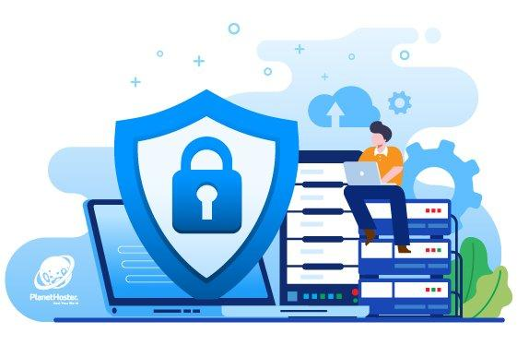

Strong cybersecurity starts with installing the strongest antivirus software on all of your computing devices. Internet security software should also protect your devices from dangerous malware as well – which is often used in identity theft crimes. Furthermore, you must keep your antivirus software up-to-date. You should also scan your computer for viruses and malware each night before turning it off.
2. Install a Firewall



The best way to protect your PC from hackers is to prevent them from accessing it to begin with. You can do that by installing a firewall. A firewall will block outside attempts to gain access to your computer. It can also protect your computer from some viruses, malware, and Trojans too. All Windows-based computers/laptops/tablets come with the Windows Firewall already preinstalled. However, most internet security software programs include the option to install a firewall as well.
3. Create a Boot Disk

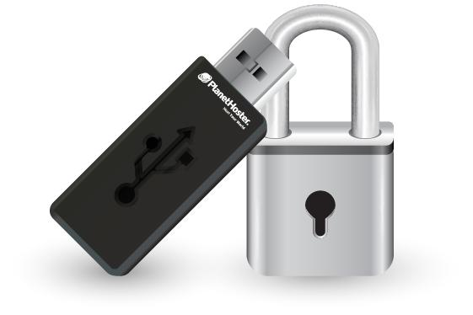

Even with the best internet security precautions, your computer could still be compromised by a malicious cyber-attack. Oftentimes, malicious software is so destructive that it can corrupt your computer’s operating system – which means you can no longer use it. Your only option to salvage your computing device is to restore it to the original (factory) settings. Therefore, you should create an emergency boot disk if one didn’t come with your device. Most people create a boot disk on a USB flash drive. You can learn how to create a boot disk by researching it further online.

KM-07-KT02 : Techniques for safety 5%
Learning Outcome

Question
2
Describe the hazards can caused by (tripping, electrical, fire, jewellery, etc.)
Electrical Safety
Electricity travels in closed circuits. Shock occurs when the body becomes a part of an electric circuit. Electric shock can cause direct injuries such as electrical burns, arc burns, and thermal contact burns. It can also cause injuries of an indirect or secondary nature in which involuntary muscle reaction from the electric shock can cause bruises, bone fractures, and even death resulting from collisions or falls. Shock occurs when person in contact with ground comes in contact with any of the following:
- Both wires of the electric circuit
- One wire of the energized circuit and the ground
- A metallic part that has become energized by being in contact with an energized wire.
The severity of the shock received when a person becomes a part of an electric circuit is affected by three primary factors:
- The amount of current flowing through the body.
- The path of the current through the body.
- The length of time the body is in the circuit.

KM-07-KT03: System components 5%
Learning Outcome

Question
3
Describe the storage devices such as hard drives, magnetic tapes, flash drives functions
Types of storage devices
Explore the many devices designed to boost your digital storage capacity and discover how they work.
Share this

Storage capacity is no longer dependent on the physical capacity of your computer. Many options exist to hold your files while saving storage space on your computer, phone, or tablet. If your devices are slow and running out of space, you can offload files onto a physical storage device. Or better yet, use the best storage technology and save your files to the cloud.
Cloud storage
While not exactly a device per se, cloud storage is the newest and most versatile type of storage for computers. “The cloud” is not one place or object, but rather a huge collection of servers housed in data centres around the world. When you save a document to the cloud, you’re storing it on these servers.
Because cloud storage stores everything online, it doesn’t use any of your computer’s secondary storage, allowing you to save space.
Cloud storage offers significantly higher storage capacities than USB flash drives and other physical options. This saves you from having to sift through each device to find the right file.
While external HDDs and SSDs were once favoured for their portability, they, too, fall short compared to cloud storage. There aren’t many pocket-friendly external hard drives. While they’re smaller and lighter than a computer’s internal storage drive, they are still tangible devices. The cloud, on the other hand, can go with you anywhere without taking up any physical space, and without the physical vulnerabilities of an external drive.
External storage devices were also popular as a quick solution for transferring files, but they’re only useful if you can access each physical device. Cloud computing is thriving as many businesses now operate remotely. It's likely that you wouldn’t mail a USB drive overseas to send a large file to a colleague. Cloud storage acts as a bridge between remote workers, making collaboration from afar a breeze.
If you forget to bring a hard drive containing important documents to a meeting, there’s not much you can do other than go back and grab it. If you break or lose a hard drive altogether, it’s unlikely you’ll ever get that data back. These risks don’t exist for cloud storage—your data is backed up and accessible whenever and wherever you are so long as you have access to the internet.
With Dropbox, you can access any file in your account from your desktop. It’s just like storing your files locally only they don’t use up any of your disk space. Keeping all your files saved in Dropbox means they’re always one click away. You can access them from any device with internet connection, and share in an instant.
External storage devices
In addition to storage media contained within a computer, there are also digital storage devices that are external from computers. These are commonly used to expand storage capacity on a computer that runs low on space, allow more portability, or provide easy file transfers from one device to another.
And if you want to transfer files from external drives to the cloud, you can use external drive backup and access your files from anywhere.
External HDDs and SSDs
You can get both HDD and SSD devices as external drives. These generally offer the largest storage capacity among external options, with external HDDs offering up to 20 TB of storage and (reasonably-priced) external SSDs offering up to 8 TB of storage.
External HDDs and SSDs work in the exact same way that their internal counterparts do. Most external drives can connect to any computer; they’re not tied to one device, so they’re a decent solution for transferring files across devices.
Flash memory devices
We mentioned flash memory earlier when discussing SSDs. A flash memory device contains trillions of interconnected flash memory cells that store data. These cells hold millions of transistors that when switched on or off represent 1s and 0s in binary code, allowing a computer to read and write information.
One of the most recognizable types of flash memory device is the USB flash drive. Also known as a thumb drive or a memory stick, these small, portable storage devices have long been a popular choice for extra computer storage. Before it was quick and easy to share files online, USB-flash drives were essential for easily moving files from one device to another. However, they can only be used on devices with a USB port. Most older computers have a USB port, but newer ones may require an adapter.

KM-07-KT04: Motherboards
Learning Outcome
Topic elements to be covered include:
Question
4
Outline the components of a Computer System
Given below are the 5 components of a computer along with their purpose and functions.
- Input Unit
A computer will only respond when a command is given to the device. These commands can be given using the input unit or the input devices.
For example: Using a keyboard we can type things on a Notepad and the computer processes the entered data and then displays the output of the same of the screen.
The data entered can be in the form of numbers, alphabet, images, etc. We enter the information using an input device, the processing units convert it into computer understandable languages and then the final output is received by a human-understandable language.
- Output Unit
When we command a computer to perform a task, it reverts for the action performed and gives us a result. This result is called output. There are various output devices connected to the computer. The most basic of which is a monitor. Whatever we write using a keyboard or click using a mouse, is all displayed on the monitor.
Thus, the output unit gives us the final result once the entire processing is done within the mechanism of a device.
For example: when we visit an ATM, we enter our details like language, pin, amount to be withdrawn, etc. and then the final money which the cash dispenser releases is our outcome. In this case, the cash dispenser acts as an output unit.
To get a list of computer input and output devices and the function of the various I/O devices, visit the linked article.
For better understanding and more interactive analysis of the components of the computer, candidates can check the video given below and get detailed information reading the five major components responsible for the functioning of a computer device.
- Memory Unit
When we enter the data into the computer using an input device, the entered information immediately gets saved in the memory unit of the Central Processing Unit (CPU). Because of the presence of some existing programming, the Memory Unit transmits the data further to the other parts of the CPU.
Similarly, when the output of our command is processed by the computer, it is saved in the memory unit before giving the output to the user.
- Control Unit
This is the core unit which manages the entire functioning of the computer device. It is one of the most essential components of the computer system.
The Control Unit collects the data entered using the input unit, leads it on for processing and once that is done, receives the output and presents it to the user. It can be said to the centre of all processing actions taking place inside a computer device.
Basically, the instructions taken, interpretation of entered data, issuing signals to execute the data and then finally retrieving the data is all done in the Control Unit.
- Arithmetic & Logical Unit
As the name suggests, all the mathematical calculations or arithmetic operations are performed in the Arithmetic and Logical Unit of the CPU.
It can also perform actions like a comparison of data and decision-making actions. The ALU comprises circuits using which addition, subtraction, multiplication, division and other numerical based calculations can be performed.
Central Processing Unit (CPU)
The Central Processing Unit is the core of any computer devices. It comprises three major components of the computer which have been discussed above:
- Memory Unit
- Control Unit

KM-07-KT05: Processors 5%
Learning Outcome

Question
5
Describe the basic computer Terminologies
1. CPU
CPU means ‘Central Processing Unit’. This is the place of computer data handling. Moreover, it does all the data manipulation, calculations and formatting data for output. Hence, whenever someone buys a computer, he/she becomes more conscious about the CPU and its capabilities.

The execution of the instructions within the computer system is very fast. It measures it in cycles of time and refers it to as megahertz. That’s why the ‘Mhz’ of a computer’s processor is sometimes referred to as the clock speed. Think about CPUs (and aligned circuitry) beating like a heart, this pulsing/beating is expressed as “MHz” e.g. 2000Mhz.
2. RAM
Specifically, RAM stands for “Random Access Memory” or “Ready Access Memory”. It is a temporary notepad where your computer sends information to disk, or to the storage place of instructions from other input devices. The term “random access” indicates that memory locations in RAM are accessible in any order unlike sequential access of a data cassette tape.
3. Hard-disk Drive
Your computers hard disk drive is like an audio CD that you possess at home – except your computer can read and write to it. In other words, your computer can take data from your hard drive (to process it in the CPU or place it in RAM to work with).
Also, it can record the results of the work it does back to the disk, which is “writing to disk”. The abbreviation HDD stands for “hard disk drive”.
If you open your HDD, you would find a pancake stack on double-sided disks.
4. Floppy Disk
You can also read and write data in a floppy disk. Simply, it is smaller than HDD and portable – you can take it to another computer and read from it there also. Floppy disks are sometimes called “secondary storage devices”. They were known as ‘floppy’ originally because they were 5¼ inches in width and floppy. They could carry almost 720kb of data. Today, however floppy disks are smaller, rigid, and can carry more data like 1.44Mb.
5. Hardware
Hardware is the term referring to all the physical parts in a computer system. It includes the monitor, the keyboard, the mouse, the main case which stores the RAM, CPU and the motherboard.
6. Software
‘Software’ is the term which refers to the instructions needed to make a computer work. It is intangible in nature. The software is also known as a “program”. Also, it is a set of computer files which are used to perform various actions on the computer. You can have a program for ‘word processing’. The software can be transferred to a compact disk and floppy disks, but usually, sit on the computer’s hard drive waiting to be “run”.

KM-07-KT06 : Memory 5%
Learning Outcome

Question
6
Explain the types of memory: ram and rom including dram, sram, cmos ram, and vram
Types of RAM
As you've probably noticed, RAM is a sort of universal name for memory. Beyond that, each new name refers more to the mode of operation than an actual type of memory. The "D" in DRAM refers to the dynamic access. The "S" in SRAM and SDRAM refers to synchronizing the chip to the motherboard. EDO RAM refers to the extended data output whereby the column address isn't turned off after a read.
Dynamic RAM (DRAM)
First, dynamic means moving or always changing. In dynamic RAM, electricity always has to be moving through the chip to keep refreshing the memory. DRAM is the basic type of memory chip, and everything that came later was mainly a way to get address information faster. Dynamic also means that data can be moved into or out of memory, over and over again, for as long as power is available.
Data in a DRAM chip is stored in very compact form, with each bit using only its own capacitor and accompanying transistor. Once again, if the capacitor has a charge, the computer reads that as a 1. If it does not have a charge, it's a 0. Capacitors have a tendency to leak their charge fairly quickly. For that reason, they often have to be refreshed. The controller refreshes the DRAM sequentially during any given operation.
Synchronous RAM (SRAM)
SRAM introduced a clock that was actually built onto the memory module. This allows the module to be synchronized to the motherboard clock, introducing the term synchronous, or synchronized memory. Another feature of SRAM chips was that they weren't as dense as DRAM. The chips used a matrix of 6-transistors and no capacitors. Transistors don't require power to prevent leakage, so SRAM didn't have to be refreshed on a regular basis. By staying charged, the data changed only when a register changed, making the chips a lot faster than DRAM.
Because of the extra space in the matrix, SRAM uses more chips than DRAM for the same amount of storage space. Manufacturing costs are higher, so although DRAM was slower, the higher density and lower cost still made them popular in many machines. However, combining the best of both technologies quickly led to the development of SDRAM chips.
CAUTION
L-2 memory caches are usually on SRAM, which is extremely fast (as fast as 7–9 ns and 2–5 ns for ultra fast SRAM). Level 2 cache is usually installed in sizes of 256KB or 512KB.
SRAM is also used for CMOS configuration setups and requires a small amount of electricity, provided by a backup battery on the system board, to keep its data. It comes on credit-card-sized memory cards, is available in 128KB, 256KB, 512KB, 1MB, 2MB, and 4MB sizes, and has a battery life of 10 or more years.
Synchronous DRAM (SDRAM)
When the concept of synchronizing a memory chip to the motherboard proved successful, the idea was retrofitted to DRAM chips. Synchronous DRAM synchronizes the interrupt requests to the motherboard and works just like SRAM, only with the higher density (and lower cost) of the DRAM chip. Most SDRAM controllers are built into the North bridge of the motherboard chip set.
SDRAM uses the synchronization feature to eliminate the waiting problems between the CPU and the memory controller. When the CPU is ready to access data from memory, it goes to a specified clock point. The CPU knows when operations are going to be completed and when data is going to be available. No wait states means better performance (approximately 20 percent better than EDO memory, in most cases).
As we've seen, DRAM, fast page mode, and extended data output mode all measured memory speeds in nanoseconds (billionths of a second). A 70 ns part would be a "7," a 60 ns part a "6," and so on. The lower the number, the faster the memory. With the introduction of SDRAM, this measurement became less accurate. At such short intervals, per-second time began to lose any real value. Instead, the transfer speed of the front side bus began to make more sense as a measure of speed. For this reason, SDRAM modules began to be rated as 66MHz, 100MHz, 133MHz, 800MHz, and so on.

KM-07-KT07 : BIOS and CMOS 5%
Learning Outcome

Question
7
Describe how to update your computer's BIOS
In general, your computer's basic input/output system shouldn't need to be updated that often, but sometimes you have to view or even edit your computer's BIOS.

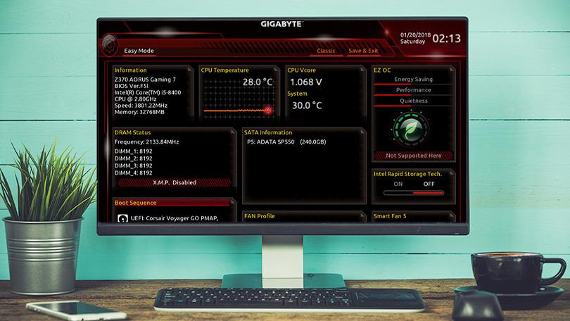
Your computer's basic input/output system—or BIOS—lives in a small chip on your motherboard, and manages the most basic instructions that allow your computer to boot into an operating system. From time to time, your PC's manufacturer may offer updates to the BIOS with certain improvements. Here's how to install them.
In general, you shouldn't need to update your BIOS that often. Installing (or "flashing") a new BIOS is more dangerous than updating a simple Windows program, and if something goes wrong during the process, you could end up bricking your computer. I don't mean to be all doom-and-gloom about it. I've never had a problem updating my BIOS, and I've done it plenty of times, but it's important to be careful.
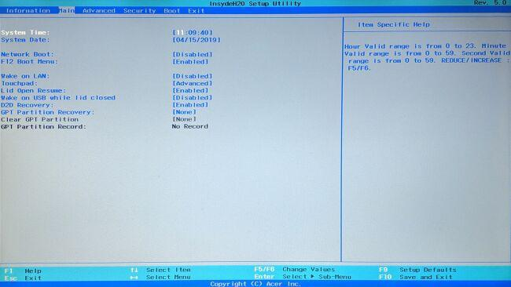
Since BIOS updates don't usually introduce new features or huge speed boosts, you probably won't see a huge benefit anyway. Unless the latest BIOS comes with security patches, support for new hardware you plan to use, or fixes a bug that's been plaguing your daily usage, you're best off leaving it alone altogether. If you fall into one of those categories and need to update your BIOS, though, here's how to do it.

KM-07-KT08 : Hard drives and storage devices 5%
Learning Outcome

Question
8
What Does Hard Disk Drive (HDD) Mean?
A hard disk drive (HDD) is a non-volatile computer storage device containing magnetic disks or platters rotating at high speeds. It is a secondary storage device used to store data permanently, random access memory (RAM) being the primary memory device. Non-volatile means data is retained when the computer is turned off.A hard disk drive is also known as a hard drive.
Hard Disk Drive (HDD)
A hard drive fits inside a computer case and is firmly attached with the use of braces and screws to prevent it from being jarred as it spins. Typically, it spins at 5,400 to 15,000 RPM. The disk moves at an accelerated rate, allowing data to be accessed immediately. Most hard drives operate on high-speed interfaces using serial ATA (SATA) or serial attached technology. When the platters rotate, an arm with a read/write head extends across the platters. The arm writes new data to the platters and reads new data from them. Most hard drives use enhanced integrated drive electronics (EIDE) including cables and connectors to the motherboard. All data is stored magnetically, allowing information to be saved when power is shut off.
Hard drives need a read only memory (ROM) controller board to instruct the read/write heads how, when and where to move across the platters. Hard drives have disks stacked together and spin in unison. The read/write heads are controlled by an actuator, which magnetically reads from and writes to the platters. The read/write heads float on a film of air above the platters. Both sides of the platters are used to store data. Each side or surface of one disk is called a head, with each one divided into sectors and tracks. All tracks are the same distance from the centre of the disk. Collectively they comprise one cylinder. Data is written to a disk starting at the furthest track. The read/write heads move inward to the next cylinder once the first cylinder is filled.
A hard drive is divided into one of more partitions, which can be further divided into logical drives or volumes. Usually a master boot record (MBR) is found at the beginning of the hard drive and contains a table of partition information. Each logical drive contains a boot record, a file allocation table (FAT) and a root directory for the FAT file system.

KM-07-KT09: Power supplies and voltage 5%
Learning Outcome

Question
9
Describe the affecting system hardware and components
Whatever you use your PC for, from playing mini roulette to browsing for the latest bargains, there will always come the point when it behaves unexpectedly. When it’s slow, often people feel powerless to do anything about it. Most of this stems from ignorance about the workings of their PC. This article will help you understand computer speed and what affects it. After reading this article, you’ll know what to look for when you want to increase computer speed and have a machine that runs as smoothly as possible.

NUMBER OF CORES (PROCESSORS)
The CPU is where you’ll find the processing units, each one known as a core. Every core will contain a control unit, ALU, and registers. Usually, a PC will have either two or four cores, and the more you have, the more programs you can run at the same time.
However, if you think that you can double your computer speed by doubling the number of cores, then think again! As they have to communicate with each other, this takes some of the speed away, but in general, increasing the number of cores is a great idea and will boost performance.

MULTIPLE APPLICATIONS AFFECTING COMPUTER SPEED
Any kind of computer speed test will indicate a decrease in performance with an increase in the number of tasks running. Multitasking slows down your PC because applications have less memory to themselves. The more apps running at the same time, the slower your PC will be. It’s something to keep in mind when optimizing performance on your machine.

GRAPHICS CARD TYPE
When it comes to visuals, the user interface, pictures, videos, and more, a powerful graphics card is imperative to good performance. If you are using your PC to process a lot of graphics, you may want to know how to speed up computer performance by optimizing your graphics card in the BIOS, or you could purchase a more up-to-date one and swap the old one out. Graphics cards can be used to perform nonvisual computations, too, so don’t forget that they are important for general performance.

DATA BUS WIDTH
Between the processor and main memory, you have a series of connectors or wires known as the data bus. This is what helps transport data between these two components. When you increase your bus from 32 to 64 bit, you will be able to transfer at least twice as much at any given time. If you want to improve performance, think about increasing the size of your data bus.

MEMORY CACHE
Computers often reuse actions, so in light of this, the cache is a type of memory that holds temporary instructions so that they needn’t be computed unnecessarily. The CPU automatically makes checks in the cache for any instructions before requesting data from the RAM. By doing this, performance is increased because it saves using data unnecessarily. These transfers take a lot less time than a transfer to and from the RAM. The larger the cache, the more data can be stored close to the CPU.

KM-07-KT10 : Ports, cables, and connectors 2%
Learning Outcome

Question
10
Describe what are AC-DC Converters
Electric power is transported on wires either as a direct current (DC) flowing in one direction at a non-oscillating constant voltage, or as an alternating current (AC) flowing backwards and forwards due to an oscillating voltage. AC is the dominant method of transporting power because it offers several advantages over DC, including lower distribution costs and simple way of converting between voltage levels thanks to the invention of the transformer.
AC power that is sent at high voltage over long distances and then converted down to a lower voltage is a more efficient and safer source of power in homes. Depending on the location, high voltage can range from 4kV (kilo-volts) up to 765kV. As a reminder, AC mains in homes range from 110V to 250V, depending on which part of the world you live it. In the U.S., the typical AC main line is 120V.
AC-DC Converters steer an alternating current, as its voltage also alternates, into reactive impedance elements, such as inductors (L) and capacitors (C), where it is stored and integrated. This process separates the power associated with the positive and negative potentials.
Filters are used to smooth out the energy stored, resulting in creation of a DC source for other circuits. This circuit can take many forms but always comprises of the same essential elements, and may have one or more stages of conversion.
The AC-DC converters depicted in figure 1 is called a ‘forward converter”, which is a higher efficiency than a slightly simpler architecture; a ‘flyback converter’.
Although not discuss in detail, a flyback converter differs from a forward converter in that its operation depends upon energy stored in the airgap of the transformer in the circuit. Apart from this difference, they can utilize the same essential blocks.
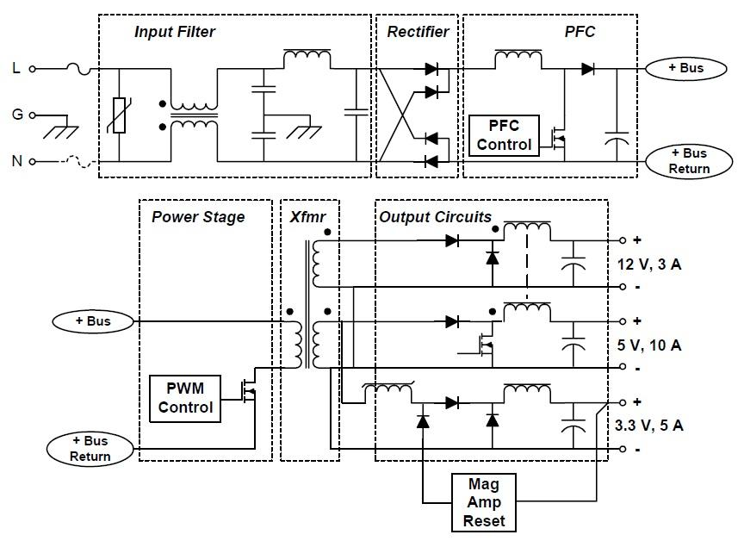
Figure 1: Functional Block Diagram of a Forward Converter AC/DC Power Supply

KM-07-KT11: Input and output devices
Learning Outcome

Question
11
Describe the functions of keyboards, mouses, and touchscreens
What is Computer Keyboard?
The keyboard is the most popular data input device in any computer system. It converts the key data to electronic signals i.e. binary digital form.
The layout of the keyboard is like that of a standard typewriter of type QWERTY. It consists of a group of typewriter-like keys that enable the entry of data into the PC.
Keyboards are of two sizes 84 keys or 101/102 keys, but now keyboards with 104 keys or 108 keys also are available for Windows and Internet. Although there are some additional keys provided for performing additional functions.

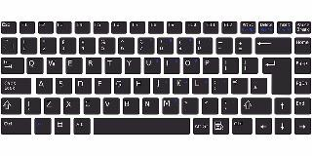
keyboard
Types of keys in a Keyboard
- Alphanumeric Keys : These keys include the letter keys (A-Z) and numbers keys (0/9).
3. Function Keys: The twelve function keys are present on the keyboard on the top. Each function key features a unique meaning and is employed for a few specific purposes.
4. Control keys: These keys provide cursor and screen control. e.g. Home, End, Insert, Delete, Page Up, Page Down, Control (Ctrl), Alternate(Alt), Escape(Esc), etc.
5. Special Purpose Keys: Keyboard also contains some special purpose keys like entering, Shift, Caps Lock, Number Lock, Space bar, Tab, and Print Screen, etc.

Types of keyboards
A keyboard may be a portable, wired, or wireless device that contains all the alphabets, numeric, symbols, and special characters, which is employed for entering input files into a laptop/personal computer system.
Keyboards are classified supported by the dimensions and their mode of usage. Those types are discussed below:
Multimedia Keyboard
The keyboard that has all multimedia buttons is named a multimedia keyboard. The buttons include play, pause, previous, next, volume up, volume down, mute and special buttons to launch media. Also, a button to launch a browser, my computer, calculator is out there.
Mechanical Keyboard
The primitive keyboard which uses physical buttons for every key’s called a mechanical keyboard. It makes noise when each key’s pressed. A button is pushed down and an electrical signal is shipped to the pc device which then shows the characters.
Wireless Keyboard
Bluetooth, IR technology, or Radio-frequency is employed to attach the keyboard to the pc device. These keyboards are lightweight and battery-powered. These keyboards should have a transmitter and trans-receiver.
Transmitter sends the strokes from the keyboard as radio waves which are received by trans-receiver kept near parent device (Computer).
Virtual Keyboard
The keyboard utilized in smartphones is named a virtual keyboard. This keyboard appears when needed and disappears when typing is completed. this will be automatically set as per need.

Mouse
The mouse is again the most popular data input device which controls the cursor or pointer while working on a computer screen/monitor.
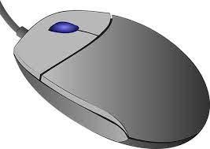
Mouse: Input Devices
Generally, the mouse contains a right button, a left button, and a wheel present between the buttons. Mouse performs various functions like opening a file or program, select menus move icons, size windows, start programs, and close windows, etc.
Types of mouse
Mechanical Mouse
A mechanical mouse features a rubber or metal ball on its underside which will appear in all directions.
Once we move the mouse then the mouse’s ball roll and sensors that are embedded inside identify the motion and move the cursor on the screen accordingly. These days, the mechanical mouse has been replaced with the Optical mouse.
It is a little palm-size box with laser light at its base, which senses the movement of the mouse and sends corresponding signals to the CPU. It allows us to regulate the pointer during a graphical user interface (GUI).
Optical Mouse
The optical mouse is a data input device, that uses laser light to detect mouse movement. It uses advanced technology like LED (light-emitting diode), optical sensor, and other DSP (digital signal processing) rather than the rubber ball mechanical mouse.
Optical mice haven’t any mechanical moving parts and no mousepads are required. Using process is when the mouse is moved, laser rays hit the surface and supply the direction to the pointer on the screen.
Other types of Mouse present in the Market:
- Infrared Frequency Cordless Mouse, Trace ball Mouse, Stylus Mouse, 3D Mouse, Laser Mouse, Track Point Mouse, Gaming mice

Joystick
The joystick is additionally a pointing or a data input device, which looks like a special remote having a spherical ball at both lower and upper ends. The lower spherical ball moves during a socket in any direction.
Functions are almost like that of a mouse. it’s mainly utilized in Computer-Aided Designing (CAD) and playing computer games.
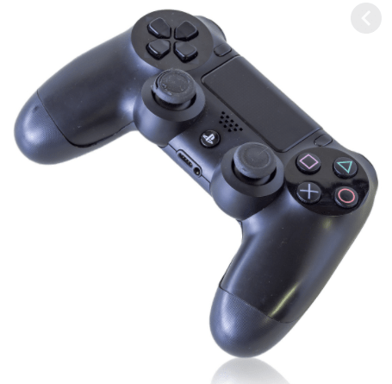
Light Pen
The Light Pen (which looks like a pen) is a pointing device that can be used to pick a menu item or draw on the computer screen.
A photocell and an optical device are enclosed in a narrow tube. When the tip of the pen is passed over the display screen and the button is pressed, the photocell sensing element detects the screen position and sends the appropriate signals to the CPU.
Track Ball
A trackball is a data input device that’s mostly utilized in a notebook or laptop pc, rather than a mouse. it’s a ball that’s half inserted and by moving fingers on the ball, the pointer is often moved.
Since all parts of the device aren’t moved, It requires less space than a mouse. A trackball comes in various shapes sort of a ball, a button, or a square.

Scanner
The scanner is a data input device, which inputs images or text printed on paper into a computer-readable format by digitizing a picture/text. it’s used when some information is out there on paper and it’s to be transferred to the hard disc of the pc for further editing or manipulation.
In short, it converts Hard Copy documents or images into softcopy (digital format)
Microphone
The microphone is a data input device to input sound/voice which is then stored in a digital form.
The microphone is employed for various applications like adding sound to a multimedia presentation or for mixing music. Sometimes it’s abbreviated as mike. The information recorded by the microphone is stored within the computer and played back later.

Microphone: A sound input device
Magnetic Ink Card Reader (MICR)
MICR is a data input device that’s generally utilized in banks as there is an outsized number of cheques to be processed a day. The bank’s code number and cheque number are printed on the cheques
It uses a special sort of ink that contains characters. When it passes through the MICR reader, the particles of magnetic material are readable by a machine and produce the desired output.
Touch Screen
A touch screen is a computer screen that often serves as an input device. A user communicates with the device by pressing pictures or words on the screen, which are responsive to pressure.
When you touch your phone, an electric circuit is completed at the point where your finger makes contact, and the electrical charge at that position is changed.
A touchscreen is a system that combines an input (‘touch panel’) and output (‘display’) device.
Instead of using a mouse, touchpad, or other such items, the touchscreen allows the user to communicate directly with what is displayed.
Optical Character Reader (OCR)
OCR is an input device (or scanner) that can read a printed text, special characters (such as alphanumeric keys and numeric characters) printed paper, and feed it to the pc data. it’s used as a lightweight source to read characters printed on paper.
OCR scans the text optically, character by character, converts them into a machine-readable code, and stores the text on the system memory.

Bar Code Readers
Bar Code Reader is one sort of data input device used for reading bar-coded data (data within the sort of light and dark lines). Barcoded data is usually utilized in labelling goods, numbering the books, etc.
Bar Code Reader is a handheld scanner, which scans a Universal Product Code image, converts it into an alphanumeric value, which is then fed to the PC for further use.

KM-07-KT12: Installing and managing printers
Learning Outcome

Question
12
Describe the installing and managing printers
Steps for Deploying and Operating Print Management
- Step 1: Install Print Management.
- Step 2: Open Print Management.
- Step 3: Add and remove print servers
- Step 4: View Printers.
- Step 5: Saving a custom view.
- Step 6: Manage Printers.
- Step 7: Troubleshoot Printers.
- Step 8: Troubleshoot Print Management.

KM-07-KT13: Mobile devices, multimedia, and laptop computers
Learning Outcome

Question
13
Explain what is a mobile device?
Before the invention and widespread adoption of small electronics, people used computers and machines that were tethered to the physical infrastructure. Radios, televisions, and computers needed to be connected to a power source for electricity. They also needed cords to connect them to content and programming. As technology developed, improvements were made that allowed storage of electricity and information. As batteries and storage drives became smaller and less expensive, the development of mobile devices flourished. Modern society is intertwined with mobile devices for communication, entertainment, and access to information. Mobile device definition: a portable handheld computer, small enough to be carried easily, which can function without being physically connected to a network and power source.
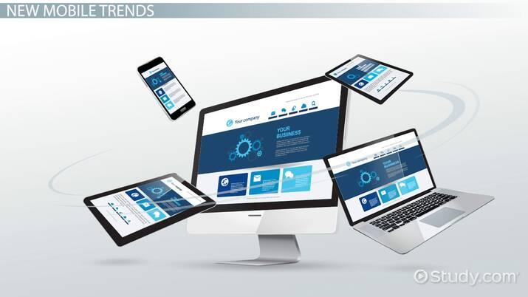
Characteristics of Mobile Devices
There is a great variety of mobile devices. Phones, tablets, e-readers, and other mobile devices share some common characteristics, including:
- Small enough to be carried easily
- Operates without a physical connection to electricity; uses a battery to store power
- Able to send and receive information wirelessly, using cellular data, Bluetooth, or Wi-Fi
- Features a user interface, such as a touchscreen or keyboard
- Includes internal data storage
- Often includes communication functions for voice or video calling
- May include sensors to record and store information, such as a camera, compass, or activity monitor
Small devices that are designed to store but not send and receive information, such as external hard drives, are not considered mobile devices.

KM-07-KT14: Preventative maintenance
Learning Outcome

Question
14
Explain preventative procedures
Common Causes of Data Loss
Data loss can be caused by many different factors, and each poses a unique problem for data recovery. Hard drive crashes account for the highest percentage of data loss, but human errors and issues with software follow closely behind. According to data from Kroll Ontrack:
1. Human Error

Humans are not infallible — we all make mistakes and sometimes they’re big ones. For businesses, these mistakes can result in the unintentional deletion of data files or sections of text. Without realizing it, employees can overwrite important files or delete information that is essential to your business. Human error can also play a role in many other main causes of data loss, including hard drive damage, liquid spills, software corruption and hard drive formatting.
One important measure to prevent human error in data handling is proper training. Ensure your employees understand how data processing within your company works and how your backup systems function. This can be as simple as knowing if the documents they are working with will be backed up automatically or if they must manually save files while they are working.
Mistakes from human error can also be minimized through several software means. Automation minimizes the amount of human interaction with data, which reduces the risk of deletion or overwriting. An optimized workflow will also leave little room for human error to occur while saving employees time and making mistakes easier to spot. Backup systems should also be used to preserve previous data states.
Recovering accidentally deleted or overwritten data can sometimes be as simple as searching through the computer’s Recycle Bin. Other times, you may be able to access previously saved versions of a document. When lost data is not as easy to retrieve, file recovery software can be a great tool. File recovery software scans your computer’s hard drive to identify and restore lost data.
2. Viruses and Malware
Most people think of viruses when you ask them what causes data losses. For businesses, viruses can steal and delete swaths of data or bring business operations to a crawl, destroying company functionality. A computer often gets a virus from an email-based attack or through phishing that tempts an employee to click on a corrupted link. This link then allows the virus or malware to enter the computer system to damage or steal files.
Guard against malware with appropriate anti-virus software. Keep your anti-virus systems constantly updated and regularly run scans to catch viruses before they can do any serious damage. Just in case a malicious program wrecks your data, be sure to make regular system backups as well. Often backed up data is the only way to recover lost data from malware or viruses.
3. Hard Drive Damage
The majority of data losses occur due to hardware malfunctions, with the primary perpetrator being the hard drive. Hard drives are the most fragile parts of computers, and around 140 thousand hard drives crash every week. Of these crashes, 60 percent are due to mechanical issues and 40 percent are a result of human misuse or mishandling, including dropping or jostling a computer or laptop. Hard drives can also be damaged if a computer overheats, typically caused by overuse or a build-up of dust in the computer.
However, as with any machine, a hard drive will wear out over time and will eventually stop working. Below are some signs to watch out for that indicate a hard drive may be failing:
- The hard drive frequently crashes
- The computer is unusually hot
- The hard drive experiences issues while booting up
- Processing speeds continually slow
- The computer freezes frequently
- The computer makes clicking or grinding noises
- Files will not open or become corrupted randomly
To prevent hard drive malfunctions, be sure to work with your device appropriately and keep your computer away from excessive dust. You can also ensure that a random malfunction doesn’t destroy your data by regularly backing up your hard drive on an external drive or cloud server.

KM-07-KT15: Troubleshooting procedures
Learning Outcome
Question
15
Describe the functions of the hardware and software tools
Hardware Tools
For every job there is the right tool. Make sure that you are familiar with the correct use of each tool and that the correct tool is used for the current task. Skilled use of tools and software makes the job less difficult and ensures that tasks are performed properly and safely.
A toolkit should contain all the tools necessary to complete hardware repairs. As you gain experience, you learn which tools to have available for different types of jobs. Hardware tools are grouped into four categories:
- ESD tools
- Hand tools
- Cleaning tools
- Diagnostic tools
Figure shows some common tools used in computer repair.
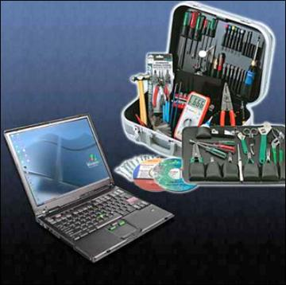
Computer Tools
ESD Tools
There are two ESD tools: the antistatic wrist strap and the antistatic mat. The antistatic wrist strap protects computer equipment when grounded to a computer chassis. The antistatic mat protects computer equipment by preventing static electricity from accumulating on the hardware or on the technician.
Hand Tools
Most tools used in the computer assembly process are small hand tools. They are available individually or as part of a computer repair toolkit. Toolkits range widely in size, quality, and price. Some common hand tools and their uses are:
- Flat-head screwdriver: Used to tighten or loosen slotted screws.
- Phillips-head screwdriver: Used to tighten or loosen cross-headed screws.
- Torx screwdriver: Used to tighten or loosen screws that have a star-like depression on the top, a feature that is mainly found on laptops.
- Hex driver: Used to tighten or loosen nuts in the same way that a screwdriver tightens or loosens screws (sometimes called a nut driver).
- Needle-nose pliers: Used to hold small parts.
- Wire cutters: Used to strip and cut wires.
- Tweezers: Used to manipulate small parts.
- Part retriever: Used to retrieve parts from locations that are too small for your hand to fit.
- Flashlight: Used to light up areas that you cannot see well.
- Wire stripper: A wire stripper is used to remove the insulation from wire so that it can be twisted to other wires or crimped to connectors to make a cable.
- Crimper: Used to attach connectors to wires.
- Punch-down tool: Used to terminate wire into termination blocks. Some cable connectors must be connected to cables using a punch down tool.
Cleaning Tools
Having the appropriate cleaning tools is essential when maintaining and repairing computers. Using the appropriate cleaning tools helps ensure that computer components are not damaged during cleaning. Cleaning tools include the following:
- Soft cloth: Used to clean different computer components without scratching or leaving debris
- Compressed air: Used to blow away dust and debris from different computer parts without touching the components
- Cable ties: Used to bundle cables neatly inside and outside of a computer
- Parts organizer: Used to hold screws, jumpers, fasteners, and other small parts and prevents them from getting mixed together
Diagnostic Tools
Diagnostic tools are used to test and diagnose equipment. Diagnostic tools include the following:
- A digital multimeter, as shown in Figure 2-3, is a device that can take many types of measurements. It tests the integrity of circuits and the quality of electricity in computer components. A digital multimeter displays the information on an LCD or LED.
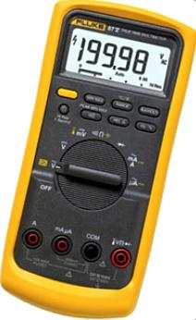
Figure 2-3.Multimeter
- A loopback adapter, also called a loopback plug, tests the basic functionality of computer ports. The adapter is specific to the port that you want to test.
- The toner probe, as shown in Figure 2-4, is a two-part tool. The toner part is connected to a cable at one end using specific adapters, such as an RJ-45, coaxial, or metal clips. The toner generates a tone that travels the length of the cable. The probe part traces the cable. When the probe is in near proximity to the cable to which the toner is attached, the tone can be heard through a speaker in the probe.
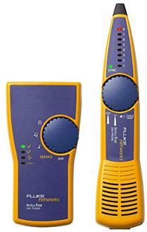
Figure 2-4.Toner Probe
Although an external hard drive enclosure is not a diagnostic tool, it is often used when diagnosing and repairing computers. The customer hard drive is placed into the external enclosure for inspection, diagnosis, and repair using a known-working computer. Backups can also be recorded to a drive in an external enclosure to prevent data corruption during a computer repair.
Software Tools
Like hardware tools, there are a variety of software tools that can be used to help technicians pinpoint and troubleshoot problems. Many of these tools are free and several come with the Windows operating system.
Disk Management Tools
Software tools help diagnose computer and network problems and determine which computer device is not functioning correctly. A technician must be able to use a range of software tools to diagnose problems, maintain hardware, and protect the data stored on a computer.
You must be able to identify which software to use in different situations. Disk management tools help detect and correct disk errors, prepare a disk for data storage, and remove unwanted files.
The following are some disk management tools:
- FDISK: A command-line tool that creates and deletes partitions on a hard drive. The FDISK tool is not available in Windows XP, Vista, or 7. It has been replaced with the Disk Management tool.
- Disk Management Tool: Initializes disks, creates partitions, and formats partitions.
- Format: Prepares a hard drive to store information.
- ScanDisk or CHKDSK: Checks the integrity of files and folders on a hard drive by scanning the file system. These tools might also check the disk surface for physical errors.
- Defrag: Optimizes space on a hard drive to allow faster access to programs and data.
- Disk Cleanup: Clears space on a hard drive by searching for files that can be safely deleted.
- System File Checker (SFC): A command-line tool that scans the operating system critical files and replaces files that are corrupted.
Use the Windows 7 boot disk for troubleshooting and repairing corrupted files. The Windows 7 boot disk repairs Windows system files, restores damaged or lost files, and reinstalls the operating system.

KM-07-KT16: Operating systems
Learning Outcome
Question
16
Demonstrate an understanding of operating systems
(An Operating System (OS) is an interface between a computer user and computer hardware. An operating system is a software which performs all the basic tasks like file management, memory management, process management, handling input and output, and controlling peripheral devices such as disk drives and printers.
Some popular Operating Systems include Linux Operating System, Windows Operating System, VMS, OS/400, AIX, z/OS, etc.
Definition
An operating system is a program that acts as an interface between the user and the computer hardware and controls the execution of all kinds of programs.
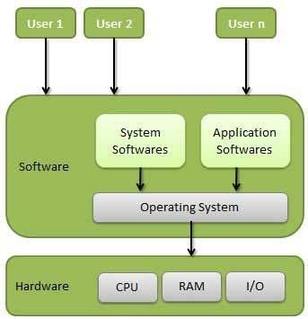
Following are some of important functions of an operating System.
- Memory Management
- Processor Management
- Device Management
- File Management
- Security
- Control over system performance
- Job accounting
- Error detecting aids
- Coordination between other software and users
Memory Management
Memory management refers to management of Primary Memory or Main Memory. Main memory is a large array of words or bytes where each word or byte has its own address.
Main memory provides a fast storage that can be accessed directly by the CPU. For a program to be executed, it must in the main memory. An Operating System does the following activities for memory management −
- Keeps tracks of primary memory, i.e., what part of it are in use by whom, what part are not in use.
- In multiprogramming, the OS decides which process will get memory when and how much.
- Allocates the memory when a process requests it to do so.
- De-allocates the memory when a process no longer needs it or has been terminated.
Processor Management
In multiprogramming environment, the OS decides which process gets the processor when and for how much time. This function is called process scheduling. An Operating System does the following activities for processor management −
- Keeps tracks of processor and status of process. The program responsible for this task is known as traffic controller.
- Allocates the processor (CPU) to a process.
- De-allocates processor when a process is no longer required.
Device Management
An Operating System manages device communication via their respective drivers. It does the following activities for device management −
- Keeps tracks of all devices. Program responsible for this task is known as the I/O controller.
- Decides which process gets the device when and for how much time.
- Allocates the device in the efficient way.
- De-allocates devices.
File Management
A file system is normally organized into directories for easy navigation and usage. These directories may contain files and other directions.
An Operating System does the following activities for file management −
- Keeps track of information, location, uses, status etc. The collective facilities are often known as file system.
- Decides who gets the resources.
- Allocates the resources.
- De-allocates the resources.

KM-07-KT17: Managing files
Learning Outcome

Question
17
Describe the copying, moving, deleting and archiving (ZIP) files and folders
Copy a file or folder
Method 1: Right-click
- Click File Explorer icon.
- Go to the location where stores your file or folder (hard drive, USB, etc.).
- Click the name of the file or folder you wish to copy.
- Right-click the highlighted file or folder and click Copy.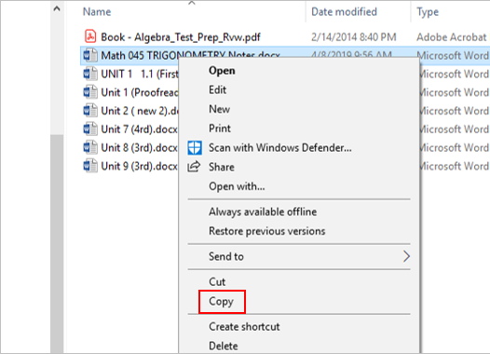
- Go to the destination folder, right-click the destination folder and click Paste.
Method 2: Ribbon toolbar commands
- Click File Explorer icon.
- Go to the location where stores your file or folder (hard drive, USB, etc.).
- Click the name of the file or folder you wish to copy.
- 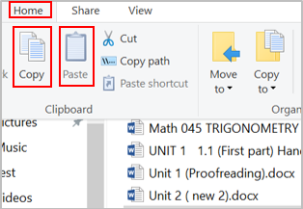Click the Home tab at the top (on the ribbon).
- Click the Copy button.
- Go to the destination location, click the Home tab.
- Click the Paste button.
Move Files or Folders
Move a file or folder (Windows 10)
Method 1
- Click File Explorer icon.
- Go to the location where stores your file or folder (hard drive, USB, etc.).
- Click the name of the file or folder you wish to move.
- Click the Home tab at the top (on the ribbon).
- Click the Move to button.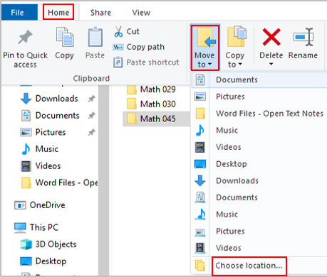
- Click Choose Location (if you don’t find the right spot on the drop-down menu).
- Go to the location you want to move for this folder.
- Click Move.
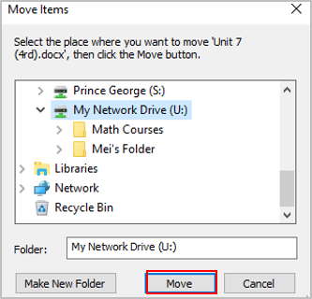
Method 2
- Click File Explorer icon.
- Go to the location where stores your file or folder.
- Click the name of the file or folder you wish to move.
- Hold down the right mouse button and drag the file or folder to the location you wish to move.
Difference between copying and moving files / folders
- Copying – make a duplicate of the selected file or folder and place it in another location.
- Moving – move the original files or folder from one place to another (change the destination).
- The move deletes the original file or folder, while copy creates a duplicate.

KM-07-KT18: Applications utility, troubleshooting, and optimization
Learning Outcome
Question
18
Describe the procedures for installing and removing utilities
How to safely download and install software


Unless you’re planning to purchase all of your software on CDs (something you likely won’t be able to do in the near future anyway), you’re eventually going to have download new software directly from websites hosting those files. That could mean downloading software directly from the company or developers. But your downloading escapades will come with the inevitable dance around sometimes suspicious-looking websites, followed by the knot you get in your stomach that maybe, just maybe, you could be downloading a nasty piece of malware.
Is it possible to safely download and install software you find online? Of course! But sometimes it takes a little bit of common sense mixed with a touch of uncommon knowledge to get the best and safest results. Let’s lay out a few helpful tips to follow while trying to weave around sketchy websites and less-than-reputable downloads.
First, check the website address
We’ve written rather extensively on the differences between secured and unsecured websites, so we won’t rehash the whole spiel here. Simply put: before downloading software from a website, check the website address. Look either for an HTTPS at the beginning of the address, or in the situations where your browser doesn’t always display the hypertext transfer protocol, look for a lock symbol. Websites with an HTTPS or lock symbol (often both) are secured through SSL/TLS encryption and have purchased a certificate to verify this fact.
This means they are, for all intents and purposes, far more difficult to hack. The files you download from those pages are far less likely to have been hijacked and less likely to be a safety concern. Websites without SSL/TLS encryption or without the requisite certificates to prove they utilize that type of security cannot guarantee you anything, even if they say they can.
For example, one would think CNET’s Download.com would be a secure, reputable place to download some new software. After all, it’s Download.com. But wait:
There’s no lock symbol and not HTTPS.
But then, sometimes websites choose to only secure specific pages. Perhaps CNET only saves the certification for where it’s needed?
Not quite. Even an antivirus software’s download page on CNET’s website has no SSL/TLS secured certification:
Does that mean you can’t trust Download.com? Not necessarily. But it doesn’t exactly confer trust in Download.com either. Despite the mostly official source (CNET has been around for on the internet for over 2 decades), the site’s lack of obtaining SSL/TLS certification is at the least somewhat confusing, considering the data protection concerns that exist on the web. They’re not alone in this, to be frank, as the larger share of software hosting sites we’ve listed at the end of this article also lack SSL/TLS certificates.
CNET’s Download.com might have highly secure servers hosting their files. We just don’t know. They haven’t bothered to purchase the certificate to verify that for us, and we could not find any information on their website detailing what security measures they employ for hosted files. We’re left to wonder whether the site is or is not secure, among some other questionable practices they use (more on that later).
Meanwhile, a somewhat smaller, mostly unknown site, Free Software Directory, is fully secured:
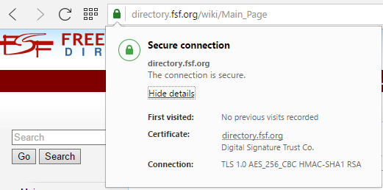
Look, we get it. SSL certificates aren’t exactly cheap to purchase. Even the lowest level SSL certificate, “Secure Site” can cost several hundred dollars a year, if not more. But if a not-for-profit website like Free Software Directory can afford to verify its security for consumers, surely a big, for-profit site like Download.com, and any other file-hosting websites for that matter can afford to do so as well.
Next, just use your eyes

This might seem a bit trite to say, but let your gut do the talking when you’ve hopped onto a website. Does it look and feel suspicious? Do you feel like your computer is catching viruses just by being connected to the web page? If so, you might want to consider moving away from that website as fast as possible. That is, of course, if your built-in web browser or antivirus software hasn’t already alerted you to the fact that the website is not safe or secure. On that end…
Use active virus and malware scanners
There’s almost no substitute for active virus and malware scanners. Not only can they scan your files before you install them, many will actually prevent you from downloading files that contain viruses and malware in them. This is a boon to you, and one of your best defenses against this kind of thing.
If you’re a Windows user, you might also want to consider turning on Windows Defender. Windows Defender is Microsoft’s built-in active malware scanner. It will actively block any attempt to download suspicious files.
If you don’t trust the site, look for the software elsewhere
Simple, right? Sometimes, it’s easier to try to locate the same program hosted on a more secure website. However, there will be times where that’s simply not possible. Some programs are so rare or uncommon that the only websites that do host them are exactly the ones you want to steer clear of. In those cases, it may still be in your best interest to use those websites but to employ a few methods to avoid getting duped into downloading the malware or files and programs you don’t actually want.
Check that the download link is really the link you’re looking for
Let’s come back to Download.com. Earlier, we mentioned that Download.com employs a few tricks we don’t particularly like. One of them is including very large advertisements on download pages that will occasionally look like download links. This is a common practice among many software hosting sites, and it’s not exactly a good one. On Download.com, that looks like this:
Instead of just giving you an obvious download link, CNET’s site places two advertisements right beside the actual download link. In CNET’s defense, you won’t see this occur with the advertisements all the time. Sometimes the ads are mostly unrelated, and it’s easy to identify which link is the correct one almost immediately.
However, the use of such ads is somewhat misleading. This method is used to build advertising revenue through more clicks, playing on the fact that the human eye tends to scan websites quickly. Many people will instinctively click the first link that looks like the right download button without thinking about it first. While you may not end up downloading unwanted software or malware if you click on such a link at Download.com, this has been known to occur with many other websites that utilize this same revenue tactic.
It’s even worse on the website FileHippo. Where would you instinctively click first on this page?

That’s right — you’d probably click the extremely large, in-your-face, official looking “START DOWNLOAD” button. FileHippo can get by with this because, well, it says “Advertisement” over the button. If you click that instead of the much less ambiguous real download link on the top right, that’s your fault.
Not every website lacking SSL/TLS certificates does this. The website TechSpot doesn’t offer misleading download links, for example:
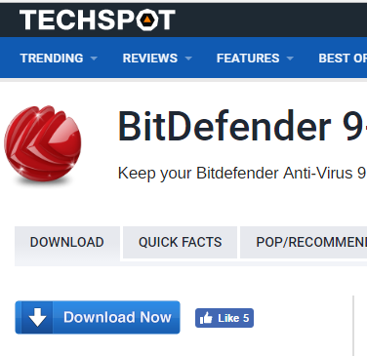
The download link you see on this website is the download link you want. You don’t get any misleading advertisements moving your eyes to other directions to trick you into hitting a link and downloading a file you don’t want.
In most cases, you can check the download link by hovering over what looks like the download, then checking the bottom of your browser. For example, when we hover over the download link on TechSpot, this is what we get at the bottom of the screen:
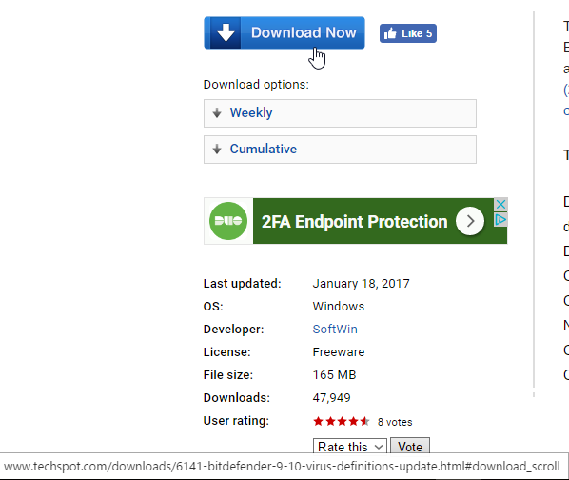
Here, we are on the BitDefender download page for TechSpot. Positively, the download link is to BitDefender. Some websites do not bring up the actual link when you hover, although you can still right-click the link, select “Copy Address” and paste the link into your address bar or a word processor to see what the link actually says.
Avoid download programs and installers
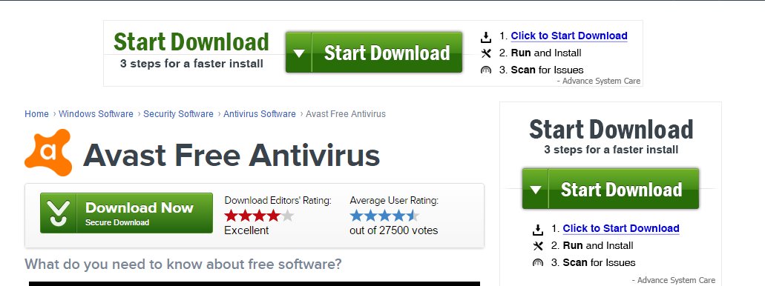
Repeat after me: I do not need a downloader or installer to install a program. Keep saying that to yourself. That way, when you run into a website that attempts to make you download a program with an installer or a download program, you’ll remember to avoid that site altogether and find that file hosted somewhere else.
These types of programs are often referred to as “potentially unwanted programs”, or PUPs. To be clear, you don’t need a download program or installer simply because every operating system you might use is designed to unpack that software file and install it, while the program itself should have installation methods built into the software. Download programs and installers are essentially extraneous pieces of software that often pair the program you want into a piece of unneeded software, commonly adware.
Know the difference between freeware, shareware, trialware, open source, and commercial software
Here are some simple definitions for you:
Freeware: any software that is completely free. You do not have to purchase it to use it.
Shareware: any software that is designed for limited, evaluation use, after which you must pay for the software to continue using it.
Trialware: a modern iteration of shareware. You can use the terms interchangeably.
Open source: any program that has openly published source code, which is available for free, and which is often continuously in development by the community.
Commercial software: any software that you must purchase in order to use.
On that end, free downloads are not the same as free software. If a website tells you that you can download a program for free, be wary. Almost all software is available to download for free. Nobody makes you pay for the action of downloading. Pay attention to that tricky wording.
Installing software safely
Once you’ve found a reputable site to download your software and you’ve hit the download button, you’re still going to have to install the program. Here are a few quick tips for when you’re at the final stage.
Make sure your active malware or virus scanner has scanned the file
If this was not done, or you lack an active scanner, some programs do let you scan the file after downloading, but before installation. Some will even allow you to single out specific programs to scan by right clicking on the file name or icon.
During installation, always choose the “Custom” installation process
Many programs will come with multiple installation options. Instead of going for the “Quick” install option, instead, choose the “Custom” option. This will let you pick and choose which features you want to be installed. Sometimes, you may find that pieces of software come packed with additional software you don’t actually want and that may actually be malware. Examine the list of options when doing a “Custom” install and uncheck anything you don’t want.
Avoid giving out your email address during installation if you can
Some programs will ask for your email address once the download is nearly complete. In some cases, this is to sign up for an account with the website or service, yet far too often it’s just so that the company behind the software can spam your email. If the software requires no account, it’s best to avoid providing your contact information.
Of course, there are exceptions to this rule. Free software which requires no registration keys to install and use certainly don’t need to have your email address. However, for paid software that requires a registration key to operate, such as the latest game or a high-quality piece of creative software, like Adobe Photoshop, it’s in your best interest to register.
The main reason is data loss. If your computer crashes, or you lose all of your data, you may be forced to reinstall the program. Some programs have one-time use registration keys that are randomly generated upon purchase. Registration can help you avoid having to repurchase an expensive piece of software.
Trusty and untrustworthy software sites
Not sure which sites you should trust the most? Here’s a list of websites that host software programs. We’ve broken them up into three categories: SSL/TLS Certified and Trustworthy, Not Certified but Trustworthy and Not Recommended.
In this case, we’ve listed a site as “trustworthy” if does not include SSL/TLS, but it avoids using sneaky and distracting ads. Any site listed as “Not Recommended” is purely based on our opinion that the site in question is not recommended due a lack of advertising its security methods through SSL/TLS certificates, or that it often uses distracting advertisements. This in no way means those sites are prone to hosting malware, nor that you will find malware on those sites.

KM-07-KT19: Configuring device drivers
Learning Outcome

Question
19
Describe the system restore points
What is restore point?
A system restore point is a backup copy of important Windows operating system (OS) files and settings that can be used to recover the system to an earlier point of time in the event of system failure or instability. It is a part of Windows XP, Vista, 7, 8, 10, 11 and Windows Server. They are created automatically or manually. System restore points only affect OS and application files, but not user data.
How do system restore points work?
The Windows system restore utility is responsible for making and using restore points. In old versions, Windows XP and Server 2003, the restore points were saved by the utility. Since Windows Vista, system restore points are made using the Microsoft Volume Shadow Copy Service (Microsoft VSS).
System restore points are designed to help the user recover the OS in the event an update, driver or application damages the OS. This way, copies of the files needed for operation are available and can be used to restore from. A system restore point can be called the last known good configuration.
The amount of hard drive space used by system restore points varies from 1% to 15%, depending on the size of the drive. If the reserved space for system restore points fills up, it will delete old copies to make space for new ones. System restore points also only store changed files -- also known as the difference -- and therefore use less storage than a full copy.
System restore is different than Windows Reset this PC or go back to the previous version of Windows.
What a restore point saves and recovers
A system restore point is primarily used for OS files and settings. It saves Windows system files and drivers. This will help in the event of a bad Windows update or system corruption. It also saves executable application data. This can be used in the event a program affects system performance or stability. The system registry and configurations are also saved.
The Windows Security Account Manager (SAM) and passwords are not backed up in restore points. Saved passwords may not be available after a system restore. This also means that a corporate domain-joined computer may lose its association to the domain after a restore and will need to be rejoined to the domain.
A system restore point is not a full backup. It does not affect user data or files. This means that a system restore point can be safely used by a user. A system restore will not delete personal files such as documents, pictures, music or videos. Be careful, though; because these files are not affected by a system restore, it cannot be used to recover these types of files if they are accidentally deleted. The Volume Shadow Copy may have copies of user files separate from system restore points though.
A system restore point is also only a local copy of the data. If the computer hardware is damaged a system restore cannot be used. It also cannot be used to transfer data from an old computer to a new one. A Windows system image may be used to create a full backup.
When system restore points are made and how to make a manual restore point
Windows will automatically make a restore point before doing most changes. This allows the system to easily rollback the change if something goes wrong. An automatic restore point is made before a Windows update is installed, an unsigned driver is installed, or a program is installed from an MSI. A restore point is also made every seven days if no other automatic restore point has been otherwise made.
Creating a manual system restore point is easy. In Windows 10 and Windows 11:
- Open the Settings app and go to the System
- From the system page open the About tab, then go to the right side under Related Settings.
- Click Advanced System Settings. This opens the System Properties window.
- From there, go to the System Protection This has all the system restore settings.
- To create a manual system restore point click the button labeled Create… and then give it a name that will help identify what the point is for.

KM-07-KT20: Networking and wireless connections
Learning Outcome
Question
20
Describe the common functionality of server networks
Using a server
A server is used to store files and run centralised applications, such as your customer database.
In the past, a server was essential. However, most businesses use cloud computing services instead.
A network server can have many roles
You can use a network server to:
- store and share your files;
- share a single internet connection between all your devices;
- manage incoming and outgoing email;
- allow staff to access files when out and about through a virtual private network (VPN);
- centralise printing, so the server manages print jobs and lets you share printers;
- run networked applications and software;
- host an intranet (a kind of private website holding important information about your business).
Businesses with many computers may need to spread the load across several servers
- Virtualisation can help you do more with a single server (see Types of system).
Some applications may dramatically slow your network if you run them on your server
They may require a separate server, used just for them. Such applications can include:
- large shared databases;
- in-house software development environments;
- complex internal email systems.
Using the cloud as a server
You can use cloud computing services (sometimes called hosted applications or Software as a Service [SaaS]) to perform many jobs that have traditionally required a server.
Cloud computing services are well suited to small or new companies with little IT expertise in-house. They are simple to set-up, cheap to operate and most come with 24/7 support if you experience problems with the service. Some businesses use a mix of server and cloud-based services.
With cloud computing, your data is held on a server located outside your business
- To access files and services, you log in through a web browser.
- Individual cloud computing services can help you with specific tasks, like backing up data or accounting.
- You can also purchase 'cloud servers' that perform all the functions of an in-house network server.
Cloud computing offers several key advantages over buying a server
- You pay monthly, allowing you to spread the cost. Overall, the total annual cost is broadly the same.
- Your cloud provider manages the administration of the server, takes backups and provides technical support.
- Cloud servers are highly flexible. You can add or remove users instantly, and you aren't usually tied into a long contract.
- Updates can take place without disrupting internal operations. Most major updates are performed outside of normal business hours, on weekends or during the night.
- Cloud servers support remote working enabling users to login from anywhere and on virtually any device.

KM-07-KT21: Recovery
Learning Outcome
Question
21
Recovery processes are identified and application is described
What is disaster recovery?
Disaster recovery (DR) is an organization's ability to respond to and recover from an event that negatively affects business operations. The goal of DR methods is to enable the organization to regain use of critical systems and IT infrastructure as soon as possible after a disaster occurs. To prepare for this, organizations often perform an in-depth analysis of their systems and create a formal document to follow in times of crisis. This document is known as a disaster recovery plan.
Read on to learn more about why DR is important, how it works, and the difference between disaster recovery and business continuity. You'll also discover what to include in a disaster recovery plan and the major types of DR, as well as major DR services and vendors.
What is a disaster?
The practice of DR revolves around events that are serious in nature. These events are often thought of in terms of natural disasters, but they can also be caused by systems or technical failure or by humans carrying out an intentional attack. They are significant enough to disrupt or completely stop critical business operations for a period of time. Types of disaster include:
- Cyber-attacks such as malware, DDoS and ransomware attacks
- Sabotage
- Power outages
- Equipment failure
- Epidemics or pandemics, such as COVID-19
- Terrorist attacks or threats
- Industrial accidents
- Hurricanes
- Tornadoes
- Earthquakes
- Floods
- Fires
Why is disaster recovery important?
Disasters can inflict many types of damage with varying levels of severity, depending on the scenario. A brief network outage could result in frustrated customers and some loss of business to an e-commerce system. A hurricane or tornado could destroy an entire manufacturing facility, data centre or office.
Additionally, many businesses are required to create and follow plans for disaster recovery, business continuity and data protection in order to meet compliance regulations. This is particularly important for organizations operating in financial, healthcare, manufacturing and government sectors. Failure to have DR procedures in place can result in legal or regulatory penalties, so understanding how to comply with resiliency standards is important.
Preparing for every potential disaster may seem extreme, but the COVID-19 crisis illustrated that even scenarios that seem farfetched can come to pass. Businesses that had emergency measures in place to support remote work had a clear advantage when stay-at-home orders were enacted.
Thinking about disasters before they happen and creating a plan for how to respond can provide many benefits. It raises awareness about potential disruptions and helps an organization to prioritize its mission-critical functions. It also provides a forum for discussing these topics and making careful decisions about how to best respond in a low-pressure setting.
What is the difference between disaster recovery and business continuity?
On a practical level, DR and business continuity are often combined into a single corporate initiative and even abbreviated together as BCDR, but they are not the same thing. While the two disciplines have similar goals relating to an organization's resilience, they differ greatly in scope.
BC is a proactive discipline intended to minimize risk and help ensure the business can continue to deliver its products and services no matter the circumstances. It focuses especially on how employees will continue to work and how the business will continue operations while a disaster is occurring. BC is also closely related to business resilience, crisis management and risk management, but each of these has different goals and parameters.
DR is a subset of business continuity that focuses on the IT systems that enable business functions. It addresses the specific steps an organization must take to resume technology operations following an event. DR is also a reactive process by nature. While planning for it must be done in advance, DR activity is not kicked off until a disaster actually occurs.

KM-07-KT22: Cloud computing
Learning Outcome

Question
22
What is the relationship between internet and network (Network vs. Internet)?
There are numerous technical terminologies present which confuse people a lot. Internet and network are two terminologies that are pegged by non-technical people the same. But, they are two opposite terms with different uses. So, in this post, explain what is the Network and the Internet and what are the difference between the internet and network (Network vs. Internet) in a constructive way.
What is a Computer Network?
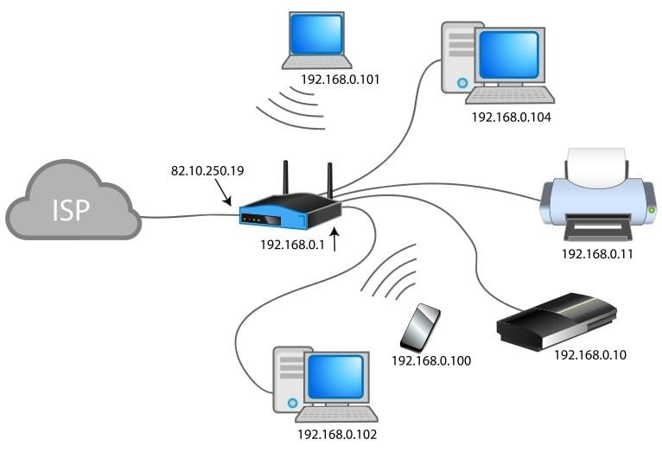
The network is a connection between two computer devices to share resources like internet connection, printer, apps, etc., It is a collection of computers or other devices that are connected with wireless technology or transmission media. The network provides connectivity between two devices present within the restricted range where one person is only authorized to manage the entire system. The network can be distinguished into different types such as –
- Local Area Network aka LAN is the network that connects the small number of devices present in the close geographical location such as nearby buildings or a floor up/down.
- Metropolitan Area Network aka MAN is a communication network that is available in large cities.
- Wide Area Network aka WAN is a network that connects two local area networks over a long distance. The operational area of WAN is vast like across countries or states.
What is the Internet?
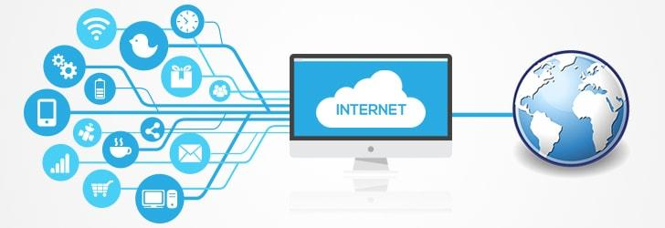
The internet (short for inter-network) is a global system that uses TCP/IP protocol suite to connect various electronic devices. It is a huge collection of interconnecting devices with speed around the globe. Internet is the network of the network which is compressed of different networks like public, private, academic, government and others. It is a type of network which connects different devices.
What is the difference between a network and the Internet?
In simple words, the network is a collection of devices that can communicate with each other on the other hand the Internet is a collection of networks that can communicate with each other.

- The network is a structure when two or more than two computers are connected to exchange data and information. On the other hand, the internet is a type of network and networks of the network, that can connect.
- The working range of the network is limited whereas the area of operation for the internet is the whole world.
- A network connecting with the three of four devices can be very affordable, but with the internet internetworking is required which can be pretty costly.
- The network is interactive over are face to face connections. The internet won’t always allow the face to face interaction.
- There are different types of networks available such as – LAN, MAN, WAN, Campus Area Network and Home Area Network. However, there’s only one type of internet presence that is the world wide web.
- The network aims to connect and complete work at a fast pace. On the contrary, the internet has soul purpose to get access to the latest news and information.
 | Network | Internet
Definition | A group of two or more computer systems are linked together. | Several networks of working that are linked together.
Location | Present within a restricted geographical area such as an institute or home. | It ranges from one country to another.
Connection | Get to interact with each other from face to face. | Do not always get to interact with each other face to face.
Types | Local Area Network, Wide Area Network, Campus Area Network and Home Area Network. | World Wide Web.
Aim | To get connected and complete work at fast rates. | To get access to news and information.
 | A computer network can have 100% private IP addresses. | The Internet requires public IP addresses
 | A computer network can exist entirely within a host and be 100% virtual. | The Internet cannot exist with only virtual devices, it includes the host.
 | A computer network can exist in a single location. | The Internet is geographically diverse

KM-07-KT23: Security fundamentals
Learning Outcome

Question
23
Describe what is a Computer Security Risk?
A computer security risk is really anything on your computer that may damage or steal your data or allow someone else to access your computer, without your knowledge or consent. There are a lot of different things that can create a computer risk, including malware, a general term used to describe many types of bad software. We commonly think of computer viruses, but, there are several types of bad software that can create a computer security risk, including viruses, worms, ransomware, spyware, and Trojan horses. Misconfiguration of computer products as well as unsafe computing habits also pose risks. Let's look at these in more detail.
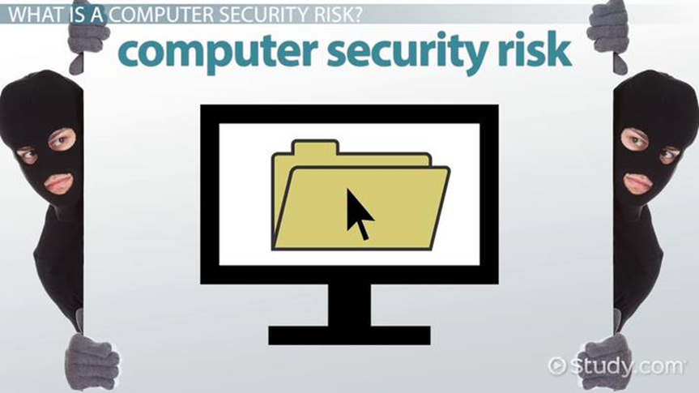
Viruses, Worms, & Ransomware
Viruses are malware that are attached to other files in your system and may be used to destroy your data. Viruses have many capabilities, but, unlike worms, they usually require human interaction to spread from system to system, even if the user is unaware they are spreading it.
Worms are like viruses, but, they have the ability to spread themselves from computer to computer, all on their own. They know how to attach themselves to portable storage devices, like USB drives or removable hard drives, or to move through the network by automatically moving to connected machines.
Ransomware is a relatively new term for malware that, when installed on your system, makes all of your files unreadable, holding your data hostage until you pay the hacker the ransom. Ransomware may be delivered by a virus or by a worm and there is no guarantee that, even if you pay the ransom, you'll get your data restored.

KM-07-KT24: Introduction to applications
Learning Outcome

Question
24
Describe the game development

Game development, like any other project, starts with an idea. The hard part is to materialize this idea into a shippable product. To achieve this, we follow specific steps.
1. DISCOVERY
It is the very first step where the idea turns into a game. Initially, the discovery stage identifies a game’s scope and what’s required to bring it to a release date.
The discovery stage usually lasts for a month or two, depending on the project scope, resources needed, and available budget. At this point, the team consists of a few members – the Core Team. The Core Team usually consists of a Solution Architect, Game Designer, and Art Director.
The discovery stage is a vital starting point of the game creation and usually implies a wide range of activities displayed in detail below:
Game Design Document Creation. Designers create a single document that has all the rules and descriptions of the game, namely:
- Game mechanics description
- User flow UX charts
- Customization design
- Metagame design
Art-Style Definition. In collaboration with Game Designers and Stakeholders, Art Director, and the teamwork on the visual style for the product, developing the aesthetics, look, and feel.
- Game visual style
  - Concepts (background/environment, characters, some iconography)
  - 3D models (characters, maybe some props like weapons)
  - 3D animations (if we have time)
  - VFX concepts/prototypes (how particle effects might look like)
- Requirements for graphics
  - Polygon budget (based on target devices)
  - Texture resolution
  - Animation requirements (animation skeleton requirements like number of bones, naming convention, folder structure)
Technology Stack Definition. At this point, Solution Architect or Tech Lead identifies the technologies needed for the development process.
- Define if the team can use an existing solution
  - Usually, it’s faster to develop a product with an available game engine
  - In some instances, it makes sense to build a custom engine or platform
- Pick among various available engines
  - Decide what engine suits best to express your idea
- Define the project architecture
  - Make sure the product is built with expansion and future support in mind
Planning. When the team is ready with the procedures mentioned above, we provide the information on:
- The team needed to develop the game
- How long it takes to develop a game
- Deliverables produced along the way
- Budget breakdown

2. PRODUCTION: THE MOST LABOR-INTENSIVE STAGE OF THE GAME DEVELOPMENT PROCESS
This is when the actual development begins. Team members polish the story, define game mechanics, its balance, pacing, and gameplay. Plus, they create all assets (characters, creatures, props, and environments), set the rules of play, build levels and scenes, and write the code.
Each component of the game has to be designed thoughtfully, the fun and gameplay, and then characters, environment, objects, the level of difficulty, scenes, and more. Because the initial ideas don’t always render well in reality, the game testing and improvement continue even when the game is released.
Let’s look at the fundamentals of game production, and some of the critical video game development jobs, bearing in mind that small teams undertake multiple roles. In contrast, a larger studio with more team players who specialize in a particular aspect of production.
Production Milestones
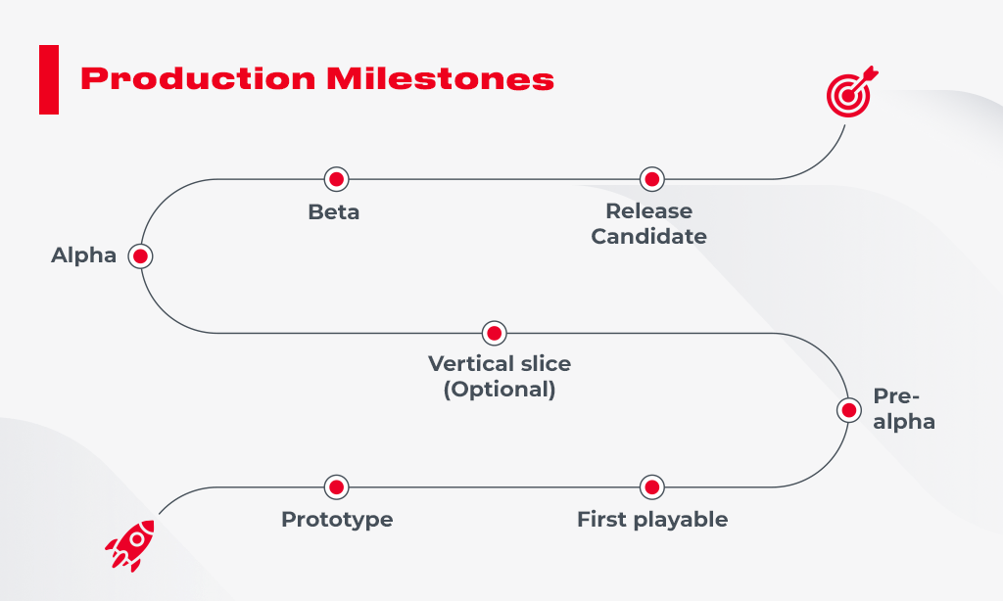
Prototype: A video game prototype is a raw test that examines functionality, user experience, gameplay, mechanics, and art style. Prototyping happens as the first phase of production to test whether the game idea will work and is worth pursuing. Many ideas fail at this stage.
First playable: The first playable allows us to get a better idea of the game’s look. While it is still far from the final version, placeholders are starting to be replaced with higher quality elements, and art is added.
Pre-alpha: Most of the content is designed in the pre-alpha stage. At this point in the game development process, some critical decisions take place. The content may get cut, or new assets are incorporated to improve gameplay.
Vertical slice (optional): A vertical slice is a fully playable version that can be used to manifest your game to clients, studios, or investors. A vertical slice gives a first-hand experience of the game, ranging from a couple of minutes to half an hour.

Alpha: The game is packed with all features, meaning that it is entirely playable from start to end. Some elements, such as art details, may still need to be added, but controls and functions should be working accurately.
Beta: Here, all the content and assets are aligned, and the team should focus on improvement rather than adding new functions or features. The QA testers ensure everything is running seamlessly and report bugs back to the side.
Release Candidate: The game is ready-to-use and can be sent to the publishing outlet and launched to the public.
The 10 Key Roles In The Game Development Process
Delivery Managers / Producers manage the business aspect of the project, particularly the expenses and schedules. Producers typically handle the budget and develop marketing strategies to sell the product.
Development Managers ensure game development runs smoothly, milestones are aligned, risks are mitigated, and teammates are doing what they’re supposed to. A project manager is often in the center of communication between the dev and design teams and executives.
Game Developers build games by turning design concepts into fully playable games. Game developers have a solid programming background. Plus, devs should have a combination of creativity, math skills, and patience to code ideas into interactive visuals and sounds.
Game Designers are the creative drivers of the game, and bridge between writers and artists, with some knowledge of programming. The game design production includes creating attention-grabbing stories, characters, goals, rules, and challenges that drive interactions between game elements.
Level Designers are responsible for creating exciting and fun levels. The challenge a level designer has to cope with is to keep a player’s focus and achieve the goal while reducing the potential of confusion. Level designers are also responsible for identifying player’s bottlenecks when going through the game, such as falling out of borders or getting stuck and not being able to get out.

